Topic Name - Array:https://www.geeksforgeeks.org/what-is-array/

Problem: Leaders in an array https://www.geeksforgeeks.org/problems/leaders-in-an-array-1587115620/1

Solution:
C++
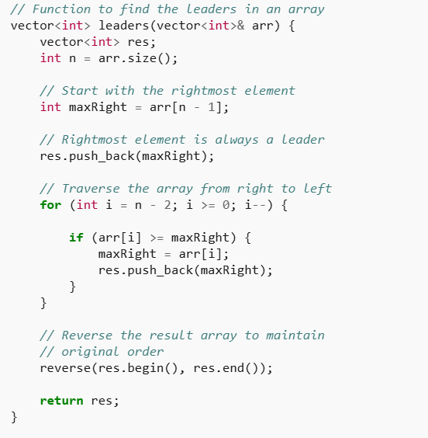
Java: 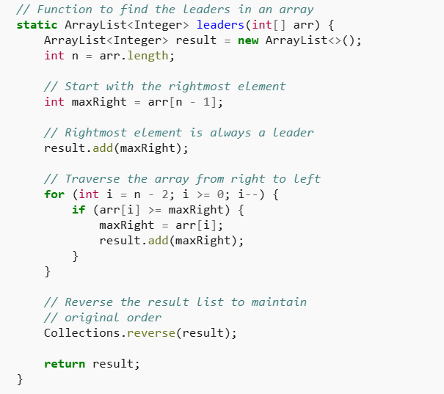

Python: 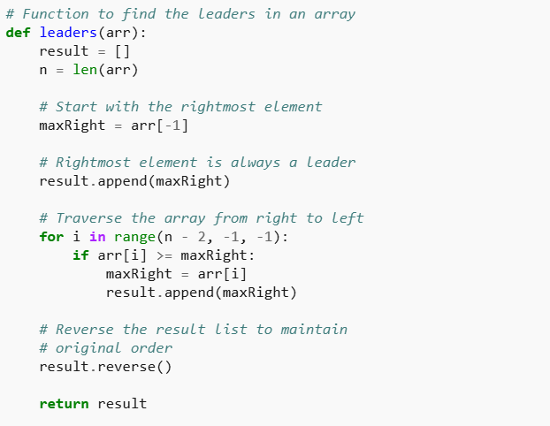

Problem: Rotate an array by d steps(left rotate)
Juggling algo: Algorithm
Reversal Algo:
C++
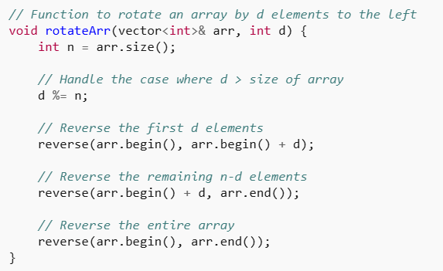

Java
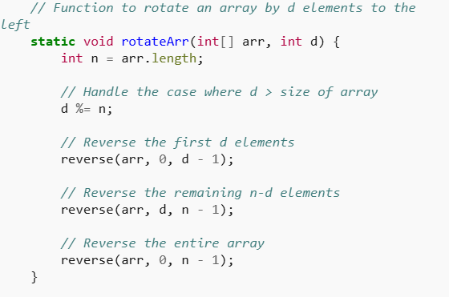

Python: 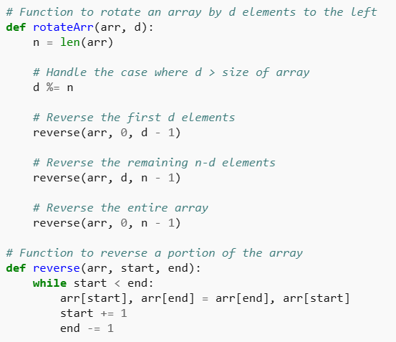

Buys and stock max one
Problem: Stock Buy and Sell – Max one Transaction Allowed

C++

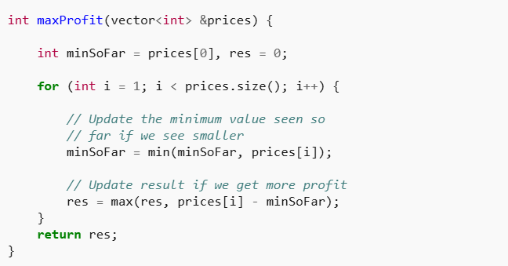

Java: 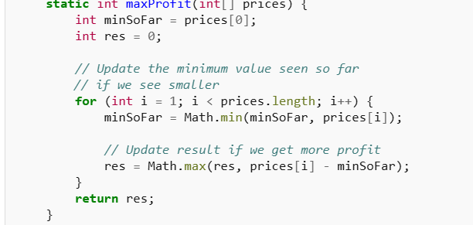Python: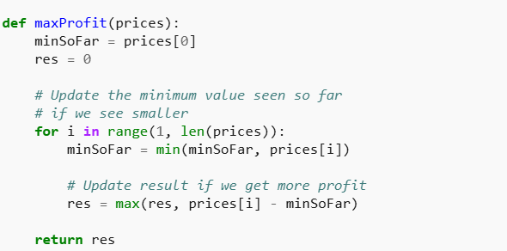

Problem: Stock Buy and Sell – Multiple Transaction Allowed

C++
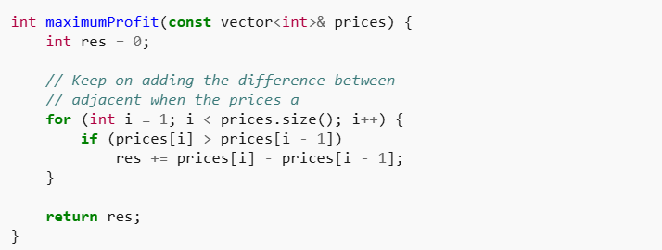

Java: 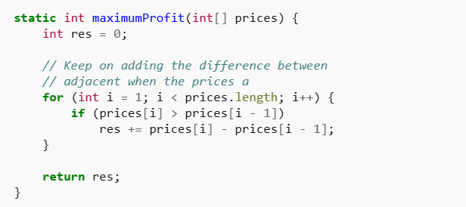

Python:
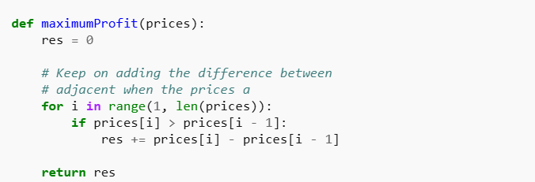

Topic - Sub array:
https://www.geeksforgeeks.org/array-subarray-subsequence-and-subset/

Problem: Maximum Subarray Sum
Solution: Kadane’s Algorithm Algo

C++
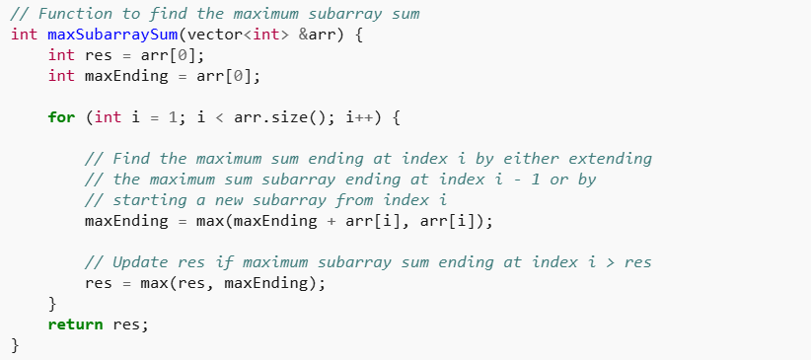

Python: 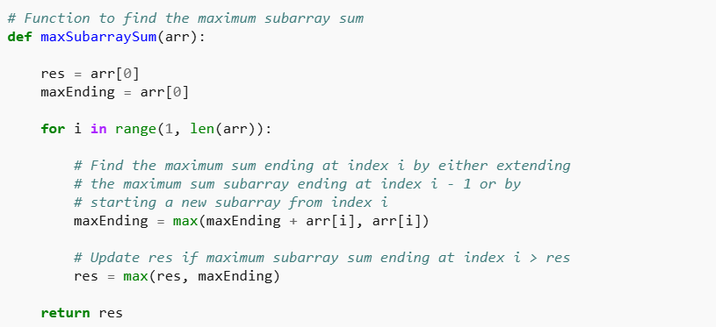

Java: 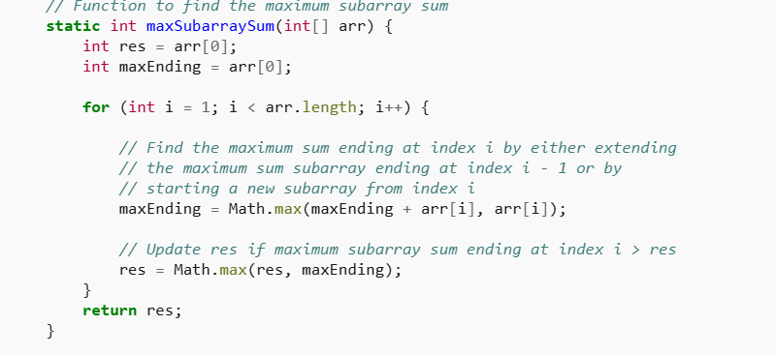

HM: Max Circular Subarray Sum

Solution :
Reference

Topic: Prefix and Suffix

https://www.geeksforgeeks.org/prefix-sum-array-implementation-applications-competitive-programming/

Problem: Equilibrium Point
Solution :
Method 1: Java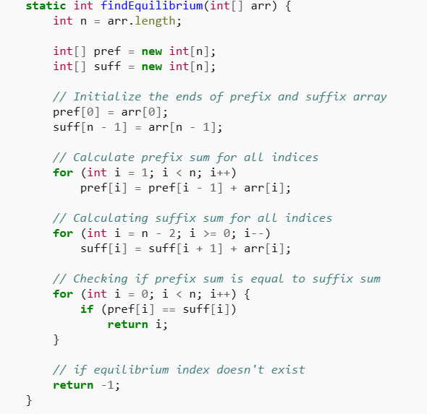
C++
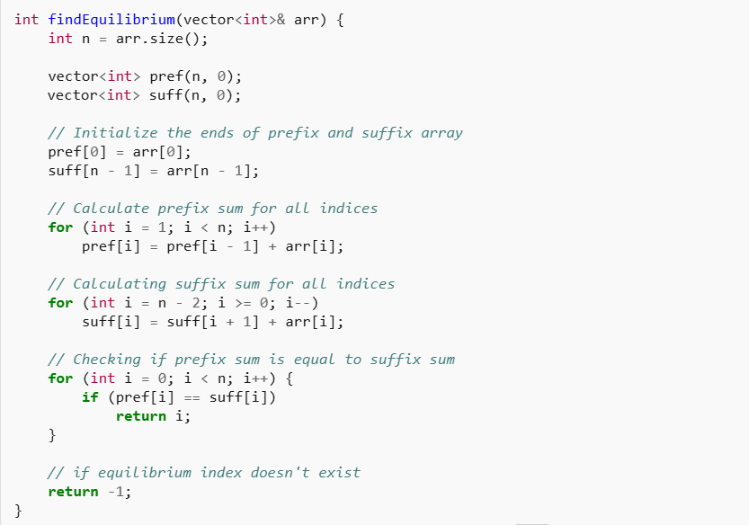

Python:
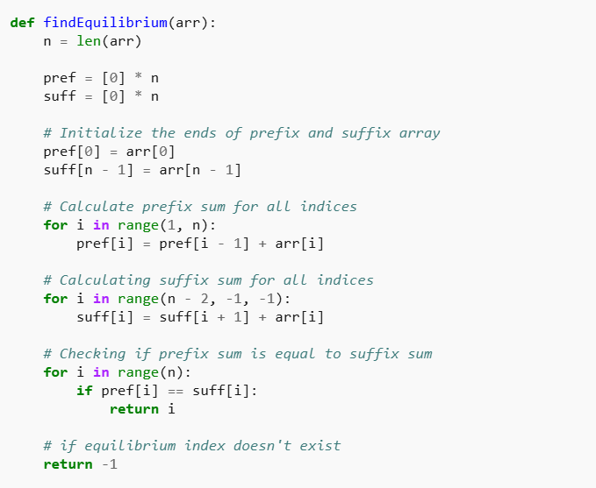

Method 2: Optimized code:
C++
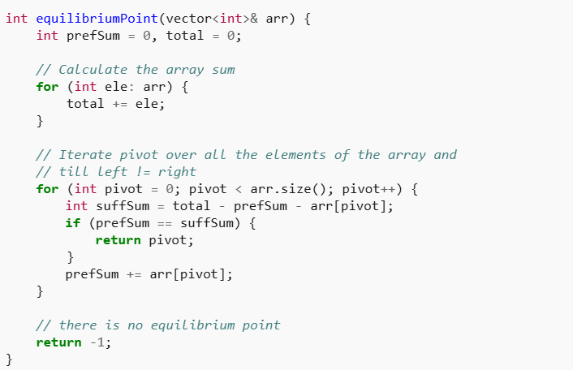

Java:
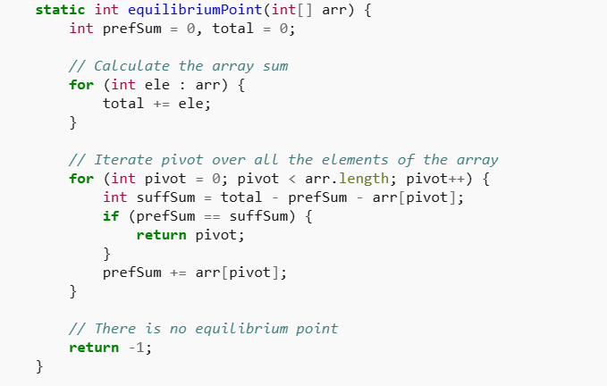
Python:
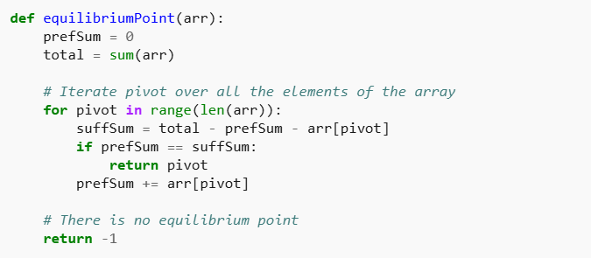

Problem: Trapping Rain Water
Solution: C++
Method 1: 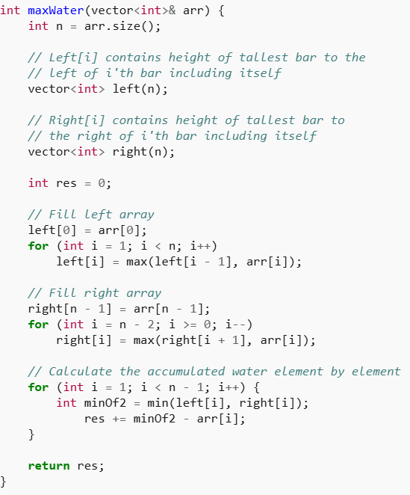

Java: 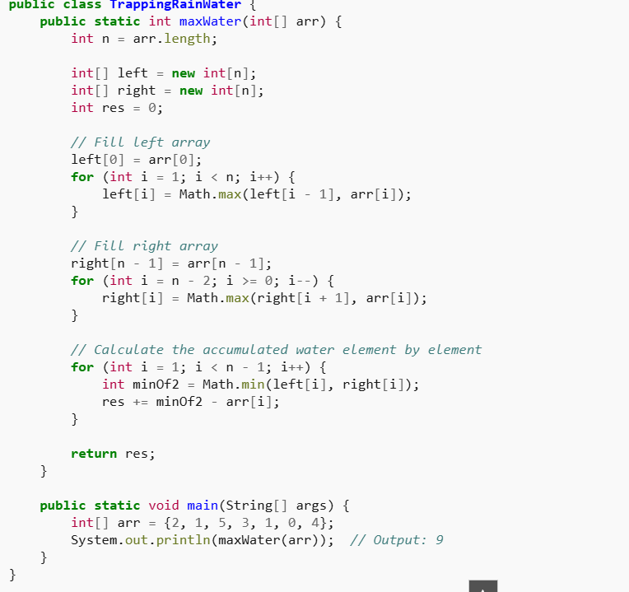

Python:
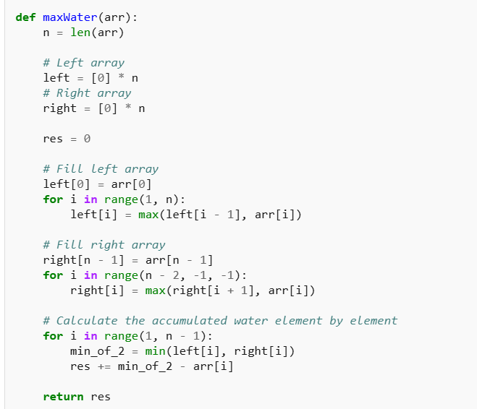

Optimized code:

C++
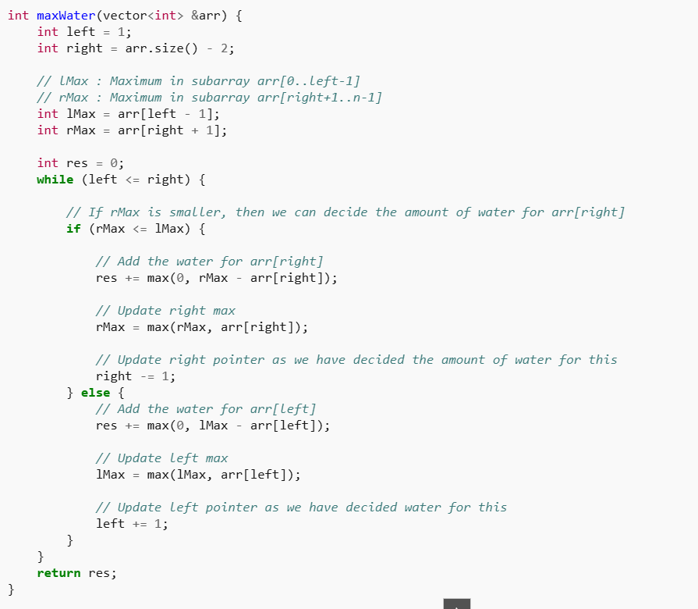

Java:
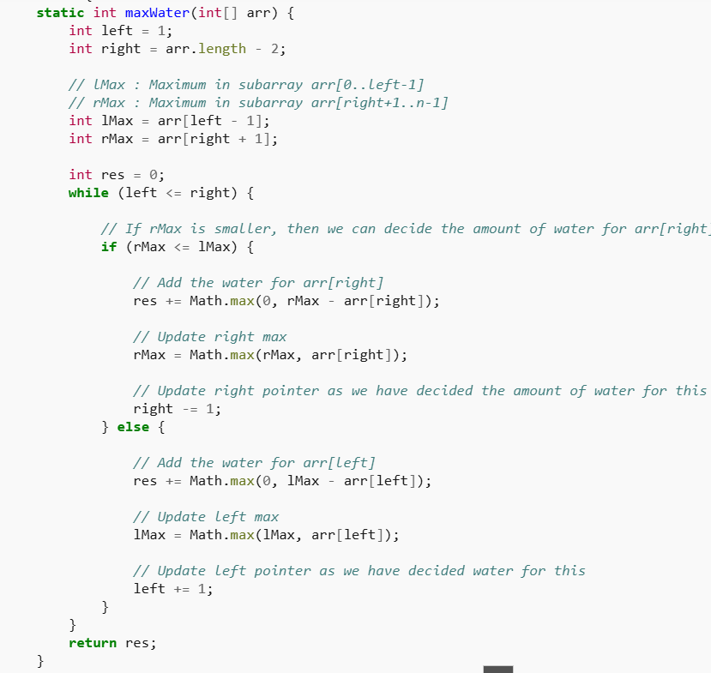

Python:
